CSC 411 Assignment 3

**1. 20 Newsgroups predictions**

**You need to report the results of three different algorithms (you are encouraged to try out more and pick 3 out of them) and the baseline.**

**BaseLine:**

BernoulliNB baseline train accuracy = 0.5987272405868835

BernoulliNB baseline test accuracy = 0.4579129049389272

**Picked Models:**

Multinomial Naïve Bayer’s (MultinomialNB)

Logistic Regression

SVM with Linear Kernel (LinearSVC)

MultinomialNB train accuracy = 0.9589004772847799

MultinomialNB test accuracy = 0.7002124269782263

The two classes that classifier was most confused about: (15, 19)

Logistic Regression train accuracy = 0.9594307937069118

Logistic Regression test accuracy = 0.6895910780669146

The two classes that classifier was most confused about: (16, 18)

LinearSVC train accuracy = 0.9588120912144246

LinearSVC test accuracy = 0.7003451938396177

The two classes that classifier was most confused about: (16, 18)

**Explain in your report how you picked the best hyperparameters.**

The model I choose is mainly one parameter driven even though it comes with more parameters in the sklearn library. I used a lot of combinations and finally picked the most import one to tune, C(Inverse of regularization strength) in Logistic regression and C(Penalty parameter) in SVM, alpha in Naïve Bayer’s Multinomial Model. I firstly found the default parameters as set in the sklearn. I increase and decrease it to see the improvement or degradation on the performance. And then I keep doing it for the benefit of higher performance. Then it comes out my best hyperparameters as shown in the code.

**Explain why you picked these 3 methods, did they work as you thought? Why/Why not?**

I did run a few other models which has been commented out in my code in order to see the difference between them. Honestly, I choose these three because they are the best compared to the rest.

Multinomial Naïve Bayer’s (MultinomialNB):

The one outperforms the others is the Naïve Bayer’s with Multinomial Model. It has above 70% accuracy on the test set which is the highest among the all. The reason behind this is practically, this model works well with document classification with tf-idf applied. And also it is very fast to train. We have more than 100K features and 10K training data. By such large training set, the languages itself would reveal some sorts of patterns for the model to follow and fit, thus yielding the second-best result here.

Logistic Regression:

Logistic Regression is able to linearly separate data. It also requires less time to train. A fact that cannot be ignored that the newsgroups is not easily separable since articles would overlap with each other for many words even though their theme does not come across each other. Thanks to the large data set provided, it is able to gain more information from features and separate them out. More related words could be grouped together under this context to get a better prediction. Thus, the performance is third-best.

SVM with Linear Kernel (LinearSVC):

SVM with linear kernel is fast and can do achieve a good performance on large dataset and features. The reason we don’t use non-linear kernels is it does not outperform the linear one and does take much time. It functions similarly when using linear kernel. So the same reasoning from Logistic Regression partially applies here. It is the best model of the three.

**For your best classifier compute and show the confusion matrix, which is a k×k matrix where Cij is the number of test examples belonging to class j that were classified as i. This part you need to write yourselves.**

[[141 4 4 0 0 0 0 1 6 5 4 1 1 4 5 8 5 12 16 31]

[ 1 278 26 11 11 46 3 1 2 3 0 12 11 6 7 3 0 2 2 3]

[ 2 10 205 27 7 14 1 1 1 0 0 5 9 0 1 1 0 0 0 2]

[ 2 16 65 279 33 7 30 1 1 0 0 3 28 1 1 0 1 1 0 1]

[ 1 16 10 32 268 6 21 0 2 0 0 3 11 0 0 1 0 0 0 0]

[ 2 24 24 2 3 293 0 0 2 1 1 1 2 0 2 1 1 1 0 0]

[ 0 4 3 9 8 4 280 8 5 5 0 1 8 1 0 0 1 0 1 0]

[ 3 0 1 4 6 0 15 289 28 0 1 0 12 7 6 0 6 1 5 2]

[ 5 3 5 0 2 0 7 31 292 4 2 4 9 3 2 1 3 4 2 4]

[ 2 1 0 0 0 1 2 0 2 321 5 3 1 0 1 1 1 2 1 1]

[ 10 5 16 8 15 5 11 24 13 30 373 16 11 16 18 14 11 10 7 7]

[ 4 11 12 3 6 7 1 4 0 4 3 298 33 0 3 1 11 3 5 4]

[ 1 3 2 17 15 5 8 9 8 1 0 3 228 5 6 0 1 1 2 2]

[ 2 1 3 0 2 2 1 3 6 4 1 1 13 309 5 1 4 0 10 7]

[ 10 7 7 0 6 3 6 6 4 3 2 5 11 6 311 2 8 0 7 5]

[ 79 4 2 0 1 1 1 3 6 5 6 7 2 19 6 354 14 19 12 96]

[ 12 0 0 0 2 1 2 6 10 3 1 19 0 9 4 2 267 8 91 22]

[ 13 2 1 0 0 0 0 2 3 2 0 6 2 3 7 0 8 303 9 9]

[ 10 0 5 0 0 0 1 7 6 6 0 7 1 5 8 2 11 9 138 8]

[ 19 0 3 0 0 0 0 0 1 0 0 1 0 2 1 6 11 0 2 47]]

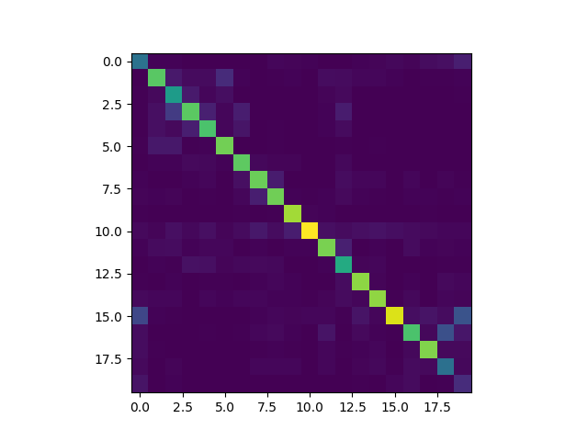

**What were the two classes your classifier was most confused about?**

(15, 19) as reported by MultinomialNB Model or (16,18) as reported both by Logistic Regression and LinearSVC Model.

**2. Training SVM with SGD**

**2.1 SGD With Momentum**

**1. Implement SGD with momentum.**

As shown in q2.py

**2. To verify your implementation find the minimum of f(w) = 0.01w2 using gradient descent. Take w0 = 10.0 and set your learning rate to α = 1.0. Plot wt for 200 time-steps using β = 0.0 and β = 0.9 on the same graph.**

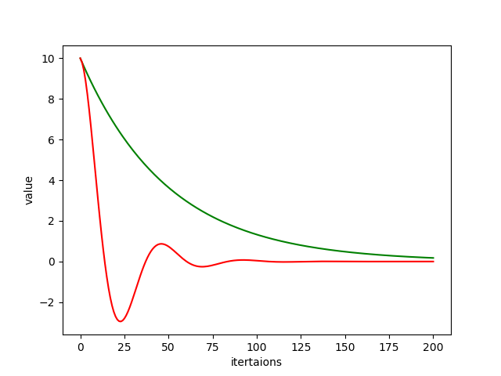

**2.2 Training SVM**

Code is as shown in q2.py

**2.3 Apply on 4-vs-9 digits on MNIST**

**Beta = 0:**

**1. The training loss:** 0.606868786012

**2. The test loss:** 0.610163921886

**1. The training loss (hinge loss average):** 0.396922546385

**2. The test loss (hinge loss average):** 0.400217682259

**3. The classification accuracy on the training set:** 0.9138321995464853

**4. The classification accuracy on the test set:** 0.9147624229234675

**5. Plot w as a 28 × 28 image.**

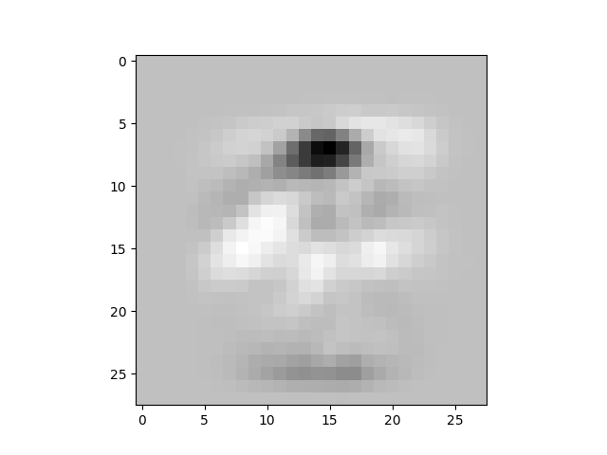

**Beta = 0.1:**

**1. The training loss:** 0.588971779765

**2. The test loss:** 0.589853506564

**1. The training loss (hinge loss average):** 0.373546602765

**2. The test loss (hinge loss average):** 0.374428329564

**3. The classification accuracy on the training set:** 0.9251700680272109

**4. The classification accuracy on the test set:** 0.9249183895538629

**5. Plot w as a 28 × 28 image.**

